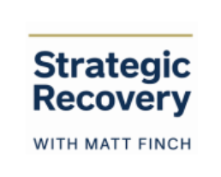

**🔥 Your Next Step: Archetype Activation Challenge**

Now that you’ve explored the 4 Archetypes of Strategic Recovery™…  
It’s time to take this from information to transformation.  
  
Because insight without action?  
It’s just another idea collecting dust.  
  
So here’s your challenge — your invitation to go deeper into who you truly are:

1. ✍️ 1. Identify Your Archetype

Which archetype resonated most with you?  
Was there one that felt like looking in a mirror?  
Or maybe two that tugged at something deep?  
  
💡 Don’t overthink it. Trust your body’s reaction — the one that made you say, “Oh… that’s me.”

1. 📓 2. Journal Prompt

“How has this archetypal pattern shown up in my life — and in my addiction?”  
Take 5–10 minutes to reflect on this.  
Look at your habits, your triggers, your strengths, and your wounds through the lens of your archetype.  
This is where awareness becomes insight.

1. 🌱 3. Reflect + Recommit

“What does my archetype need most from me right now?”  
Not someday.  
Not when life is perfect.  
But today.  
  
* Does The Seeker need grounding and presence?  
* Does The Empath need boundaries and rest?  
* Does The Achiever need stillness and self-worth beyond success?  
* Does The Thinker need embodiment and emotional risk?  
  
Let this be a mini re-alignment moment.  
Come back to yourself.  
Not who you’re supposed to be — but who you actually are.

🎯 Bonus: Take the Free Archetype Quiz

Want more clarity and a personalized roadmap?  
🎁 Take the free 4 Archetypes Quiz at:  
👉 GetStrategicRecovery.com

You’ll discover your dominant archetype, your healing blueprint, and specific tools and practices to match your nervous system, your energy, and your soul.