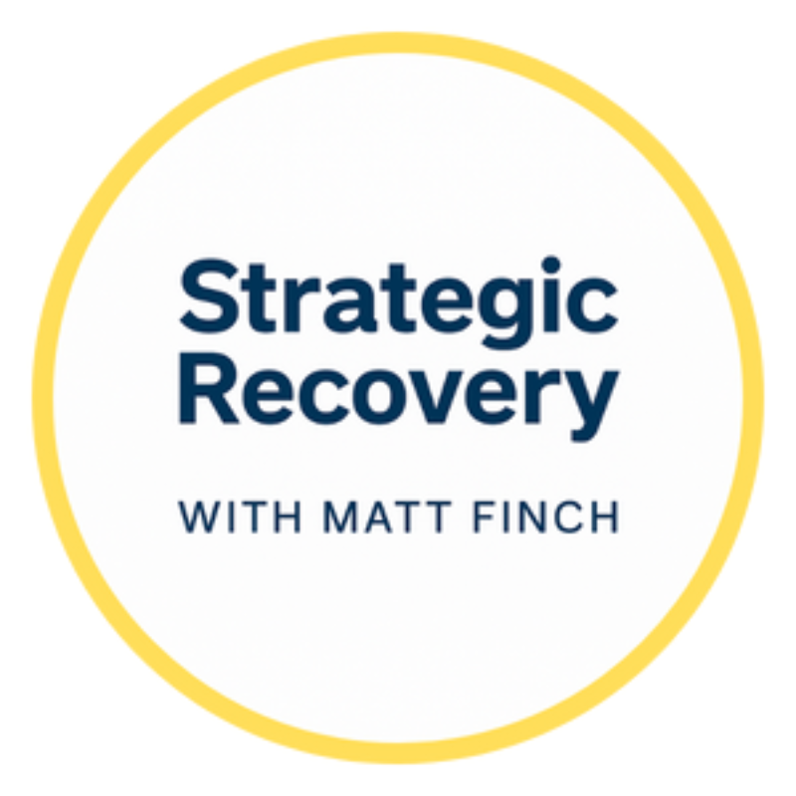
Episode 25 Companion Workbook
Designing Your Own Strategic Recovery Path

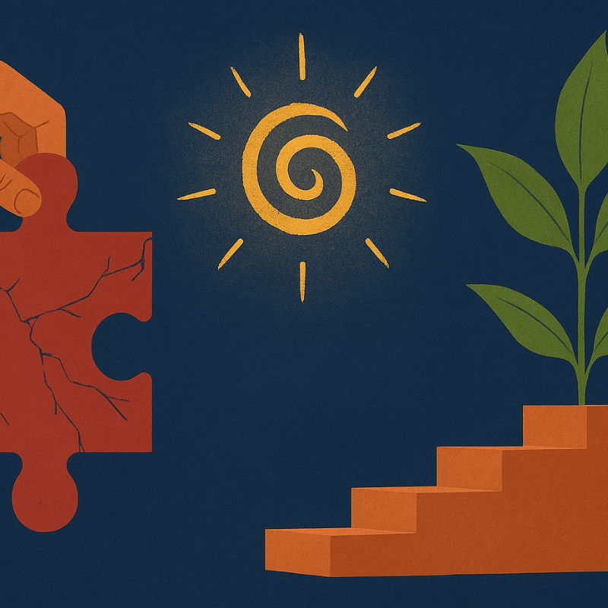
Use this workbook to translate the “any positive change” paradigm into your own daily life, across all 5 Pillars of Strategic Recovery.
https://getstrategicrecovery.com/

How to Use This Workbook
These pages are here to help you design a recovery path that actually fits your body, mind, nervous system, and soul. You can print this workbook and write by hand, or edit it directly in Word, Pages, or Google Docs.
- Move through the exercises slowly — one at a time is enough.
- Treat your answers as living, changeable experiments, not permanent contracts.
- Revisit your notes after listening to Episode 25 again in the future.
Exercise 1 – Rewrite Your Definition of Freedom
Complete the sentence below in as many ways as you’d like. You’re not trying to sound “correct” — you’re trying to sound honest.
“For me, living free after addiction means…”
____________________________________________________________________________
____________________________________________________________________________
____________________________________________________________________________
____________________________________________________________________________
Optional prompts if you get stuck:
- …being present with people I love without needing a chemical buffer.
- …trusting myself around triggers that once controlled me.
- …waking up with a clear head, a calm nervous system, and a sense of purpose.
- …knowing substances are an optional part of my life — not the center of it.

Exercise 2 – Map the 5 Pillars for Your Life
Use the chart below to rate how supported you feel in each Pillar right now, then write one realistic positive change you could make this week.
Pillar | Current Rating (1–10) | One Positive Change This Week
Biochemical
(Ex: Hydration, sleep, nutrients)
Psychological
(Ex: Therapy, journaling, beliefs)
Social
(Ex: Supportive people, boundaries)
Environmental
(Ex: Home setup, routines, triggers)
Spiritual
(Ex: Prayer, meditation, meaning)

Exercise 3 – Deconstruct a “Should”
Pick one “should” you’ve absorbed about recovery — especially one that makes you feel tight, ashamed, or boxed in. Then gently question it.
My recovery “should” is:
____________________________________________________________________________
____________________________________________________________________________
Reflective questions:
- Where did I learn this? From whom or from where?
____________________________________________________________________________
____________________________________________________________________________
- Is it absolutely, universally true for all humans?
____________________________________________________________________________
____________________________________________________________________________
- What happens in my body when I believe this?
____________________________________________________________________________
____________________________________________________________________________
- Does this belief help me move toward healing — or away from it?
____________________________________________________________________________
____________________________________________________________________________
- What would a more compassionate, nuanced belief look like for me right now?
____________________________________________________________________________
____________________________________________________________________________

Bonus Reflection – Many Roads, One Direction
Imagine your life 3–5 years from now, with your relationship to substances feeling healthy, manageable, or completely resolved. Describe what a good day in that future looks and feels like.
____________________________________________________________________________
____________________________________________________________________________
____________________________________________________________________________
____________________________________________________________________________
____________________________________________________________________________
____________________________________________________________________________
____________________________________________________________________________
____________________________________________________________________________
____________________________________________________________________________
____________________________________________________________________________

Closing Reminder
There is no single right way to walk this path. Any honest step toward more life, more presence, and more love counts. Return to this workbook whenever you feel pressured to fit someone else’s template. Your path is allowed to change as you do.
With respect and encouragement,
Matt Finch
Strategic Recovery™
More tools, essays, and episodes at https://getstrategicrecovery.com/

